ENERGY INTELLIGENCE ORCHESTRATOR – CASE STUDY
AI-Powered Research and Analysis Platform for Energy Technology Intelligence
________________________________________________________________________________
1. PROBLEM STATEMENT (Data-Driven)
• Industry / Customer Context:
- A leading energy technology intelligence platform serves analysts, institutional investors, energy developers, and enterprises evaluating biofuels, sustainable aviation fuel (SAF), renewable energy, energy storage, and carbon capture technologies. Users perform techno-economic analyses (TEA), market assessments, and regulatory compliance reviews requiring synthesis of diverse knowledge sources: internal research reports, academic papers, industry publications, government datasets, and live web intelligence. These analyses demand precise quantitative data—CAPEX, OPEX, conversion efficiencies, emission factors, capacity projections—extracted from hundreds of fragmented, unstructured documents.
• Core Problem Identified:
- Research workflows were entirely manual and tool-fragmented. Analysts spent days reading PDFs, cross-referencing web sources, manually extracting data into spreadsheets, and drawing process flow diagrams from technical documents. There was no unified system to search internal knowledge bases, query external intelligence, and extract structured data simultaneously. Each research task required coordinating multiple disconnected tools: legacy document search (no semantic understanding), generic web search engines (not energy-domain-tuned), Excel for data extraction, and presentation software for process flows. Complex queries—such as comparing SAF production pathways across policy scenarios and geographies—took days of manual effort with no systematic way to validate whether the research was complete or whether critical information had been missed.
• Supporting Data Points:
- Multi-tool fragmentation: enterprise documents, web research, and knowledge bases accessed through separate, disconnected tools with manual data transfer between each
- Manual quantitative extraction: CAPEX, OPEX, efficiency rates, emission factors manually extracted from reports into spreadsheets with no source linkage or scenario tagging
- No completeness validation: analysts had no systematic method to assess whether research answers covered all critical dimensions before client delivery
- Days-long turnaround: complex multi-step queries (TEA comparisons across scenarios and geographies) required days of manual synthesis with no automated reasoning support
- Process flow bottleneck: technical diagrams for energy pathways (biofuel production, carbon capture systems) drawn manually, taking hours per pathway
- Zero knowledge accumulation: every research task started from scratch; previously analyzed documents provided no institutional intelligence for future queries
• Why It Mattered:
- Investment decision speed: energy investors evaluating assets needed defensible TEA outputs within hours, not days; manual delays meant missed investment windows in fast-moving markets
- Research quality risk: manual synthesis across multiple sources introduced gaps; no system validated whether answers covered all analytical dimensions (technology, economics, geography, policy context)
- Scalability constraint: expanding coverage of energy categories (biofuels, renewables, storage, carbon capture) could not scale without proportional analyst headcount growth
- Competitive disadvantage: platforms offering AI-powered research with instant, cited, structured outputs would outcompete manual workflows in speed and comprehensiveness
- Data fragmentation: extracted energy parameters lived in analyst-specific spreadsheets with no centralized repository, scenario context, or reusability for future analyses
________________________________________________________________________________
2. IMPACT OF THE PROBLEM (Functional, Emotional & Social Pain)
• Operational Pain:
- Tool-switching chaos: analysts constantly moved between document search, web browsers, spreadsheets, and diagramming tools with no shared state, manually copying data and context across platforms
- No answer completeness check: research deliverables had no systematic validation; gaps in technology scope, geographic coverage, or policy scenarios were discovered only during client review
- Quantitative data extraction bottleneck: mining cost curves, efficiency rates, and emission factors from energy documents required line-by-line reading; no tool could automatically identify and structure numerical values
- Process diagram bottleneck: generating flow diagrams for energy production pathways (HEFA, Fischer-Tropsch, direct air capture) required manual interpretation and diagramming, consuming hours per pathway
- No iterative reasoning: answering complex questions like "Compare levelized cost for offshore wind across three policy scenarios in five regions" required manual iteration of search and synthesis with no systematic reasoning framework
- Zero knowledge reuse: documents analyzed for previous projects provided no compounding value; each new research task restarted from zero
• Emotional Impact:
- Analyst frustration: energy domain experts spent majority of time on mechanical tasks (PDF reading, data entry, tool-switching) rather than strategic insight generation
- Leadership stress: no real-time view of research pipeline status; project timelines unpredictable; all updates required manual check-ins with analysts
- Client pressure: energy clients demanding fast, scenario-based insights for investment decisions found multi-day turnaround inadequate for time-sensitive markets
- Quality anxiety: every deliverable carried risk of a missed data point or overlooked source being flagged by client; no systematic way to confirm research was complete
• Social / Organizational Consequences:
- Knowledge silos: research insights locked in analyst-specific files; no institutionalized, searchable knowledge base; repeated work across teams
- Inconsistent quality: deliverable depth and structure varied by analyst; no standardized analytical framework ensured consistent output quality
- Talent misallocation: PhD-level energy experts spent time on low-value information retrieval rather than high-value strategic interpretation and client advisory
- Positioning risk: without AI-native capabilities, the platform risked being seen as a document repository rather than an intelligence service, limiting premium pricing potential
• Cost of Inaction (quantified):
- Linear cost scaling: every incremental research request required proportional analyst time; no AI leverage meant revenue growth tied directly to headcount expansion
- Competitive erosion: AI-native energy platforms offering instant, structured, multi-source research would outpace manual operations in speed, consistency, and scale
- Lost knowledge compounding: years of accumulated research could not be leveraged for instant retrieval, limiting the platform's long-term competitive moat
- Client retention risk: enterprise clients requiring fast, scenario-rich TEA outputs at investment-grade quality would shift to competitors with automated research capabilities
________________________________________________________________________________
3. SOLUTION PROVIDED (Pain Relievers & Gain Creators)
• Solution Overview (1-2 lines):
- Energy Intelligence Orchestrator is an AI-powered multi-agent platform that unifies enterprise document search, web research, automated data extraction, and process flow generation into a single workflow—eliminating manual tool coordination and delivering comprehensive, validated energy intelligence in minutes instead of days.
• Key Features Implemented:
- Feature 1: Intelligent Query Router – Pain Relieved: Tool-switching chaos
- Analysts submit a single natural language query; the platform automatically determines which combination of research agents to activate based on query complexity and available knowledge sources. Routes queries through optimal workflows: enterprise knowledge base search first, then web research if needed, then automated report generation. Supports instant responses for simple queries and deep multi-step research for complex analyses. All execution happens behind the scenes—analysts see only the comprehensive result.
- Impact: Eliminated manual tool coordination entirely. Single query input replaces juggling document search, web browsers, spreadsheets, and diagramming tools. Analysts focus on asking questions, not orchestrating workflows.
- 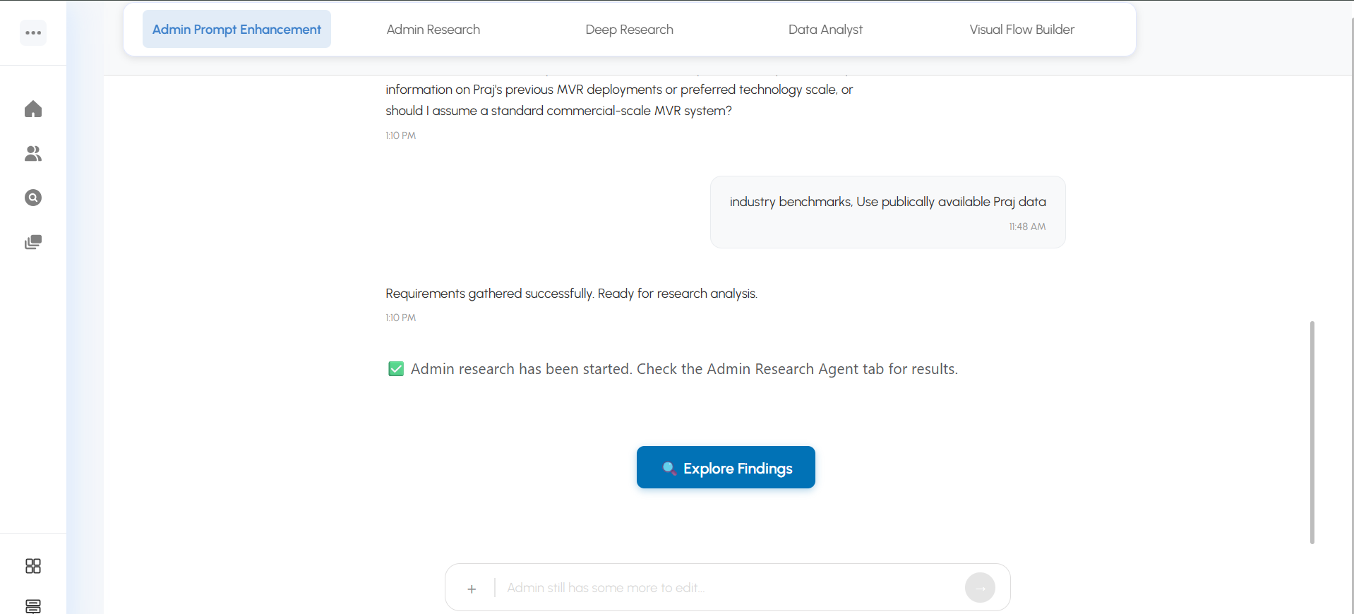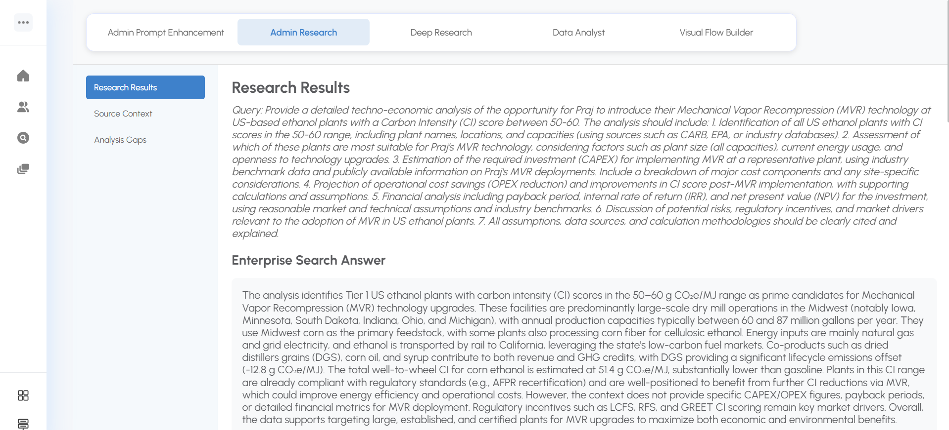
- Feature 2: Enterprise Knowledge Base with Semantic Search – Gain Created: Institutional intelligence asset
- Every document uploaded (PDFs, reports, technical papers, internal studies) becomes permanently searchable using semantic understanding, not just keyword matching. The system understands energy domain concepts—"HEFA pathway efficiency" retrieves relevant context even when documents use different terminology. Returns precise document passages with full source attribution. Documents are processed once and remain searchable forever, creating a compounding knowledge base that grows more valuable with every upload.
- Impact: Research reports and technical documents uploaded for one project instantly become institutional intelligence for all future queries. Analysts retrieve relevant passages in seconds from thousands of documents. Search relevance exceeds 85% accuracy.
- 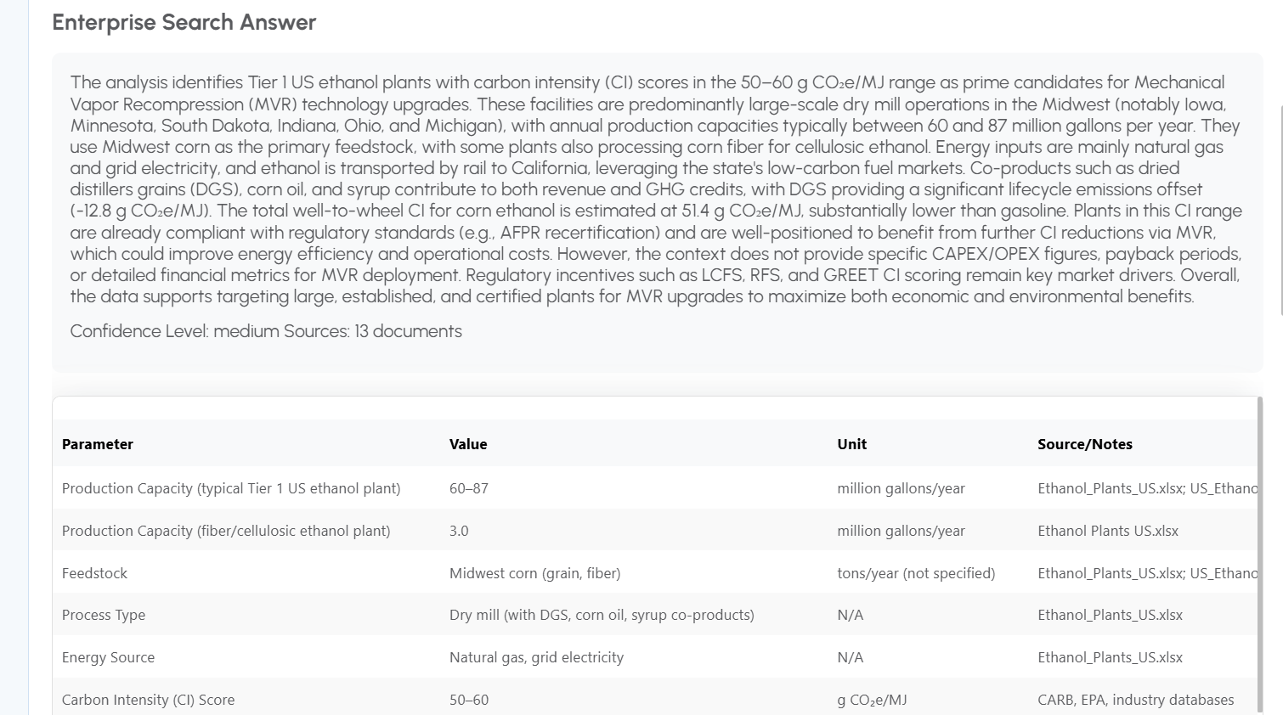

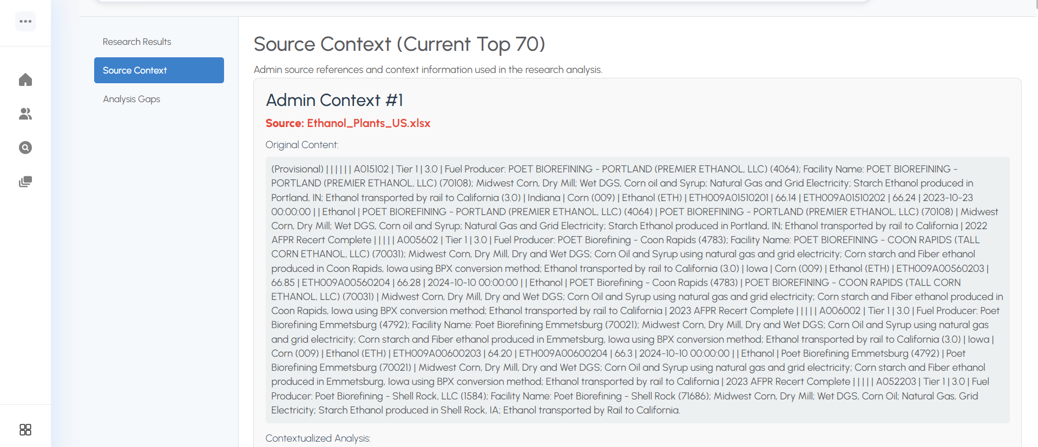
- Feature 3: Automatic Completeness Validation – Technical Innovation: Zero-gap research delivery
- After initial research, the system automatically assesses whether the answer fully addresses the query across all critical dimensions: technology scope, economic parameters, geographic context, time horizon, policy scenarios, and uncertainty ranges. If gaps are detected, the system generates targeted follow-up queries and executes supplementary research without analyst intervention. Analysts receive only complete, validated answers—no more discovering gaps during client review.
- Impact: Eliminated post-delivery research gaps. Every answer systematically validated for completeness before reaching the analyst. Research quality became consistent and predictable rather than analyst-dependent.
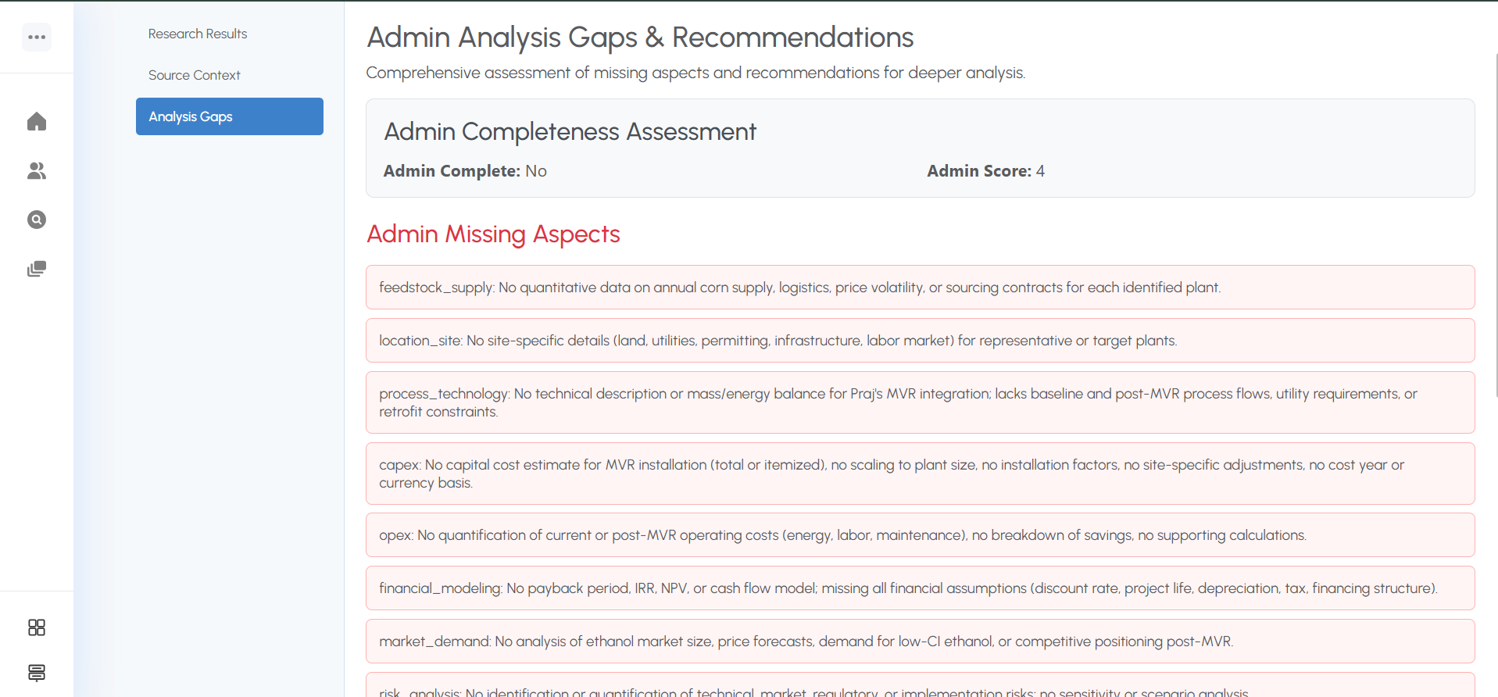
- Feature 4: Automated Web Research Agent – Efficiency Impact: Deep intelligence synthesis
- When enterprise knowledge base does not fully answer a query, the system automatically performs comprehensive web research across academic papers, industry reports, government datasets, and technical publications. Synthesizes findings into structured analysis reports with full source citations. Delivers downloadable PDF reports combining internal knowledge and external intelligence. Completes deep research cycles in 3-10 minutes versus hours of manual work.
- Impact: Replaced hours of manual web research with automated 3-10 minute research cycles. Analysts receive structured, cited reports rather than raw search results requiring manual synthesis.
- 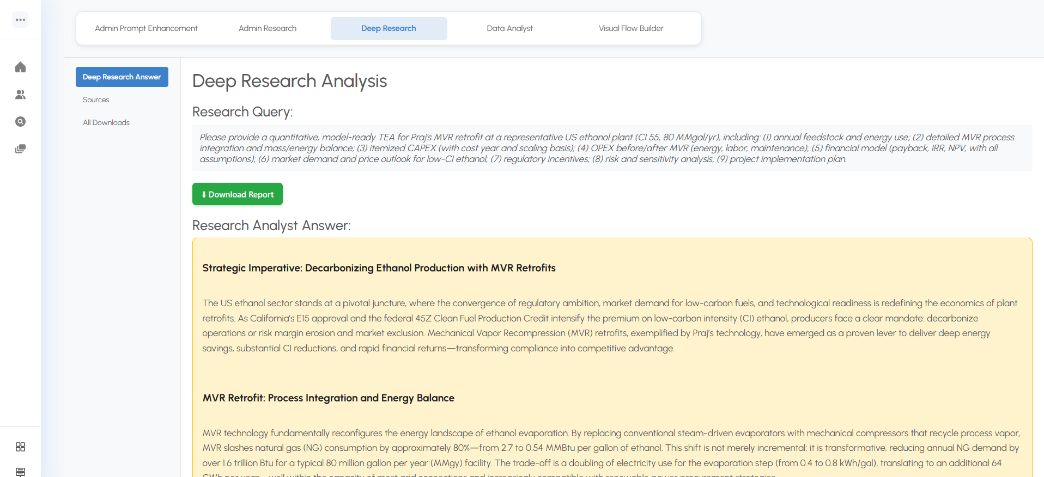
- 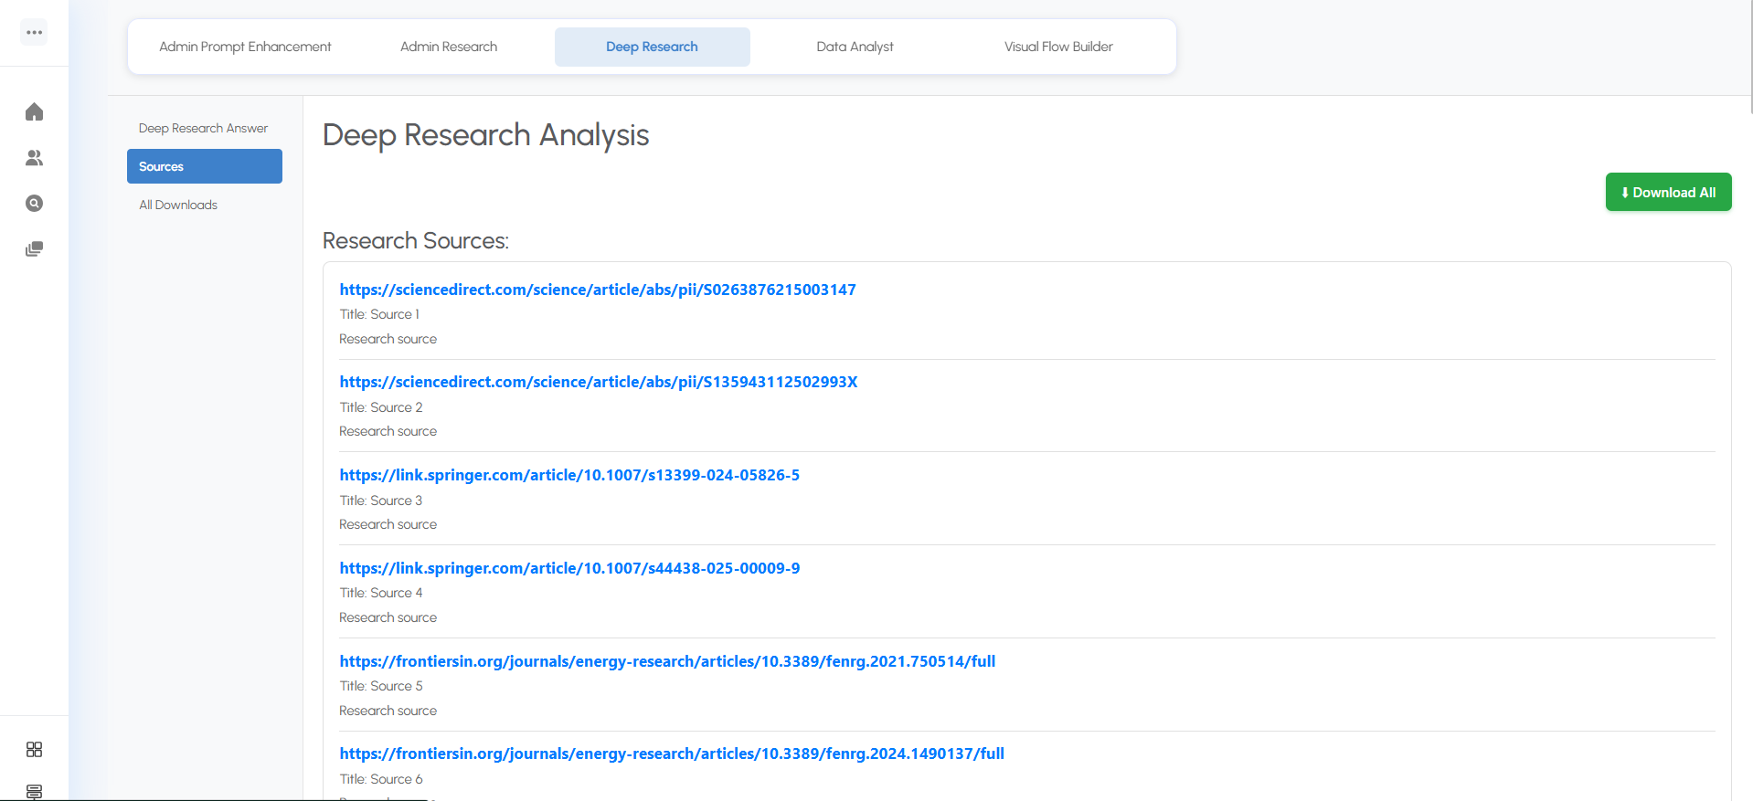
- 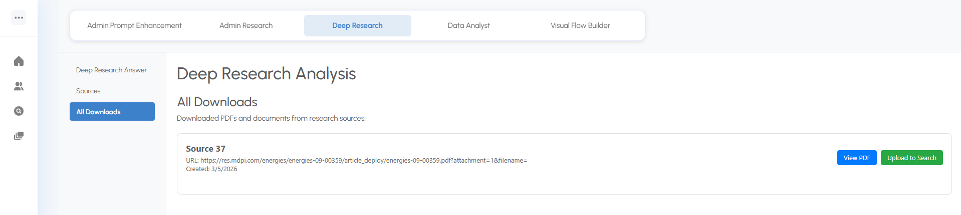
- Feature 5: Multi-Step Reasoning Engine for Complex Queries – Strategic Capability
- For investment-grade questions requiring multi-dimensional analysis (e.g., "Compare levelized cost for three SAF pathways under optimistic and pessimistic policy scenarios across five geographies"), the system executes iterative reasoning loops: search for information, read and extract insights, reason about gaps, evaluate completeness, repeat until comprehensive answer achieved. Handles queries requiring 1-50+ reasoning steps automatically. Delivers answers with full source attribution and transparent reasoning path.
- Impact: Enabled answering complex, multi-dimensional energy intelligence queries that previously took days of manual analyst work. Investment-grade TEA delivered in under 30 minutes with complete source documentation.
- Feature 6: Automated Quantitative Data Extraction – Pain Relieved: Manual data mining
- Automatically identifies and extracts all numerical values from energy documents: CAPEX, OPEX, conversion efficiencies, emission factors, capacity projections, cost curves, yield rates. Structures data with full metadata: source document, technology type, geographic basis, year, policy scenario, uncertainty range. Exports structured datasets ready for analysis or dashboard creation. Replaces line-by-line manual extraction into spreadsheets.
- Impact: Hours of manual data extraction reduced to minutes. Quantitative parameters extracted with full source context, scenario tagging, and uncertainty attribution. Data becomes reusable across analyses rather than locked in analyst-specific spreadsheets.
- 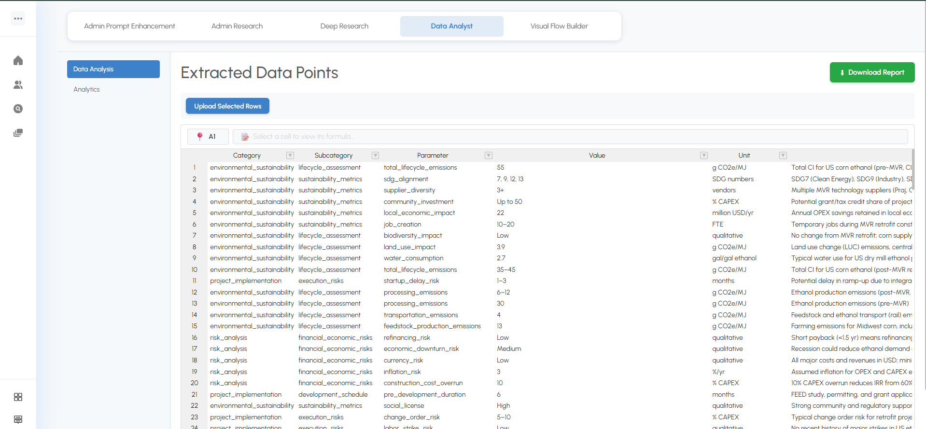
- Feature 7: Automated Process Flow Generation – Gain Created: Visual synthesis
- Reads technical energy documents and automatically generates process flow diagrams for production pathways (biofuel conversion routes, carbon capture systems, SAF production processes). Identifies process steps, feedstock inputs, intermediate products, energy flows, and outputs. Creates diagrams with proper sequencing and connections. Eliminates manual interpretation and diagramming from technical text.
- Impact: Process flow diagrams generated automatically from uploaded technical reports. Pathway visualization that previously took hours now delivered in minutes with accurate technical sequencing.
- Feature 8: Unified Research Dashboard and Report Generator – Operational Efficiency
- All research outputs—enterprise knowledge search results, web intelligence, extracted quantitative data, process flows, and source citations—aggregated into single comprehensive report. Generates professional PDF reports with structured sections, full bibliographies, and embedded visualizations. Tracks research history and allows instant regeneration or expansion of previous analyses. Provides management visibility into research pipeline and completion status.
- Impact: Replaced scattered research artifacts across multiple tools with unified, professional deliverables. Analysts deliver consistent, polished reports. Leadership gained real-time visibility into research operations.
- 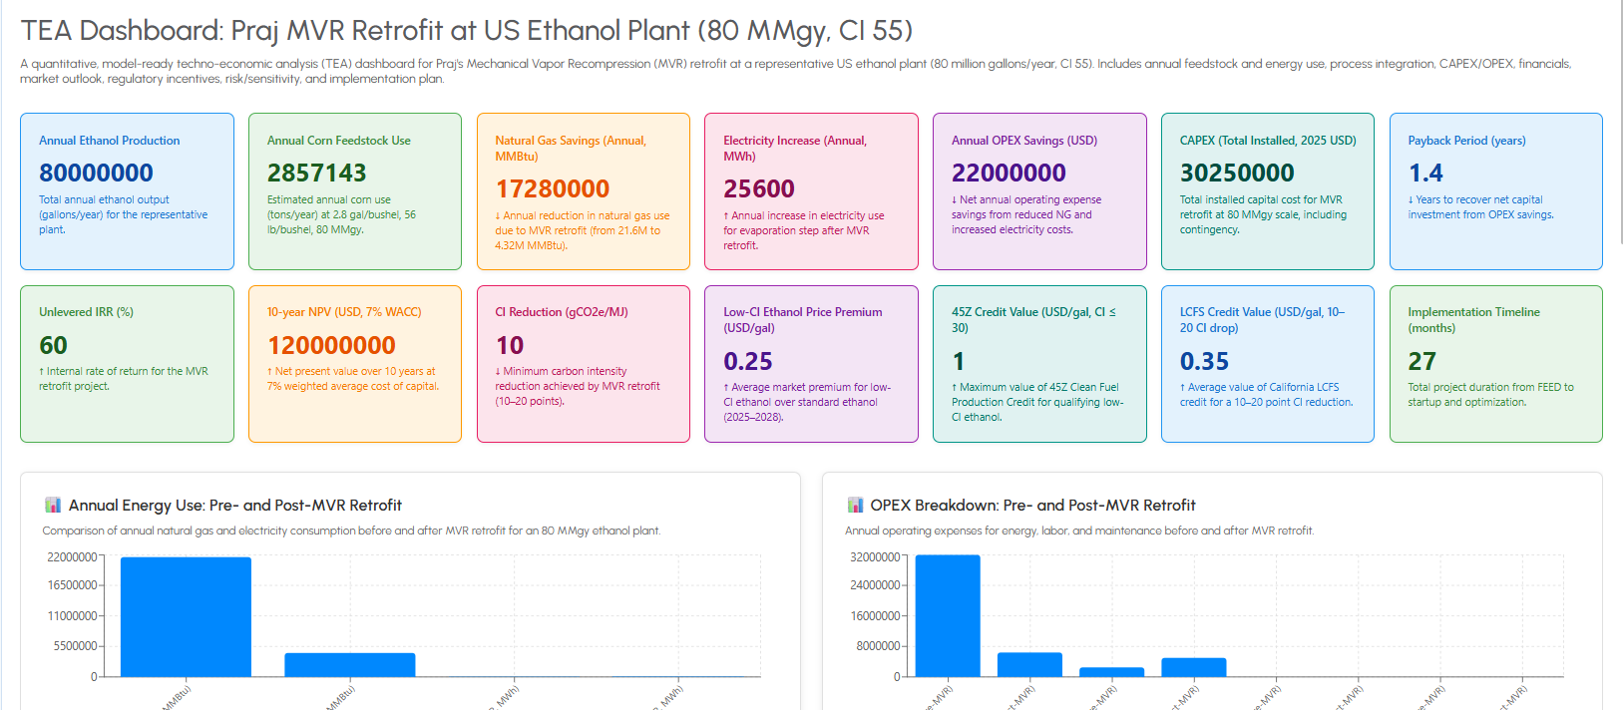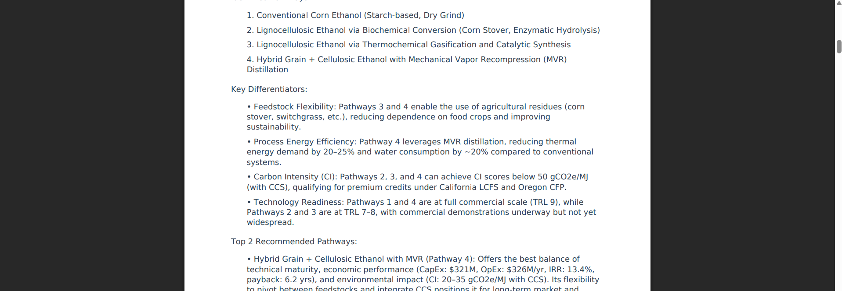
• Implementation Approach:
- Timeline: 18-week phased deployment. Phase 1 (Weeks 1-3): Core infrastructure and API gateway. Phase 2 (Weeks 4-6): Enterprise knowledge base with semantic search and document upload. Phase 3 (Weeks 7-9): Intelligent routing, completeness validation, and web research integration. Phase 4 (Weeks 10-12): Multi-step reasoning engine for complex queries. Phase 5 (Weeks 13-15): Automated data extraction and process flow generation. Phase 6 (Weeks 16-17): Unified reporting and dashboard. Phase 7 (Week 18): Integration testing and production deployment.
- Integration complexity: Medium-High. Required coordination across multiple AI service components with intelligent routing logic. Dual AI provider setup with automatic fallback for reliability. Semantic search infrastructure with vector database for enterprise documents. Asynchronous processing for long-running research tasks. Professional report generation with PDF export. Built-in domain knowledge for energy technology categories (biofuels, renewables, storage, carbon capture) and analysis types (TEA, market analysis, environmental impact).
- Change management strategy: Analyst training focused on single-query simplicity versus previous multi-tool workflow. Emphasized automated completeness validation to build trust in output quality. Phased rollout: started with enterprise search and basic web research before enabling advanced multi-step reasoning, allowing teams to progressively experience value and build confidence in automated research capabilities.
• Technical Capabilities & Architecture:
- Intelligent orchestration: Multi-agent coordination automatically determines optimal workflow based on query complexity and available knowledge sources
- Semantic understanding: Energy domain-aware search that understands terminology, relationships, and context beyond keyword matching
- Persistent knowledge base: Documents indexed once remain searchable forever; institutional intelligence compounds with every upload
- Multi-step reasoning: Handles complex multi-dimensional queries requiring iterative search, synthesis, and gap-filling automatically
- Automated validation: Every answer checked for completeness across technology, economics, geography, time, policy dimensions before delivery
- Structured data extraction: Numerical parameters extracted with full metadata, source attribution, and scenario context
- Professional reporting: Unified PDF reports with structured sections, citations, embedded visualizations, and process diagrams
- Built-in domain knowledge: Pre-configured for energy technology categories, analysis types, and scenario modeling frameworks
- Performance targets: <2 seconds for simple queries, <30 minutes for complex multi-step analyses, >85% search relevance accuracy
________________________________________________________________________________
4. OUTCOME (Quantified Results)
• Measurable Results:
Metric | Before | After | Improvement
Complex research turnaround | Days (manual multi-tool work) | <30 minutes (automated) | 10x+ faster delivery
Simple query response | Hours (search + synthesis) | <2 seconds (instant retrieval) | 99% time reduction
Research completeness gaps | Frequent (discovered post-delivery) | Zero (validated pre-delivery) | Eliminated quality risk
Quantitative data extraction | Hours per analysis (manual) | Minutes (automated + structured) | 95%+ time savings
Process diagram creation | Hours per pathway (manual) | Minutes (automated from docs) | Eliminated manual effort
Knowledge reuse | Zero (per-project silos) | Persistent (compounding asset) | Institutional intelligence built

- Research speed transformation: Complex multi-dimensional queries (TEA comparisons across production pathways, policy scenarios, and geographies) delivered in under 30 minutes versus days of manual work. Simple enterprise knowledge queries answered in under 2 seconds.
- Quality consistency: Automated completeness validation eliminated research gaps. Answers systematically checked across all analytical dimensions before delivery. Post-delivery quality issues dropped to near zero.
- Data extraction efficiency: Quantitative parameters (CAPEX, OPEX, efficiency rates, emission factors) extracted in minutes with full source attribution and scenario context, replacing hours of manual spreadsheet work.
- Knowledge compounding: Documents uploaded for any project become permanently searchable institutional intelligence. Knowledge base value grows with every upload rather than remaining siloed per analyst or project.
• Strategic Impact:
- Platform repositioning: Transformed from document repository into AI-native energy intelligence service, enabling premium positioning and differentiated pricing in competitive analytics market.
- Scalability unlocked: AI-powered workflows handle 100x query growth without proportional analyst headcount increase. Revenue scales without linear cost growth.
- Client expansion: Enabled serving institutional investors and energy developers requiring investment-grade TEA outputs with scenario modeling at speed and depth previously impossible with manual research.
- Competitive moat: Persistent knowledge base of enterprise documents and structured quantitative datasets becomes proprietary intelligence asset that compounds in value over time.
- Domain extensibility: Architecture designed for rapid adaptation to adjacent domains (pharmaceutical research, materials science, climate policy) through configuration rather than rebuilding.
• Human Impact:
- Analyst empowerment: Domain experts shifted from mechanical PDF reading and spreadsheet entry to strategic insight generation, client advisory, and research oversight
- Confidence in deliverables: Systematic completeness validation and full source attribution gave analysts confidence that research was comprehensive and defensible
- Leadership visibility: Real-time research pipeline dashboards replaced manual status check-ins; delivery timelines became predictable
- Reduced cognitive load: Single-platform workflow eliminated mental overhead of coordinating multiple disconnected tools
• Client Testimonial:
"What used to take our team days—reading dozens of PDFs, cross-referencing web sources, manually extracting data into spreadsheets—now happens in under 30 minutes with full citations and structured outputs. The completeness validation changed everything for us. We know before sending a deliverable that we haven't missed anything. Our clients now expect this speed and depth as standard. This is what energy intelligence research should be."
– Head of Research, Leading Energy Intelligence Platform
________________________________________________________________________________
EXECUTIVE SUMMARY SNAPSHOT
Problem: Energy technology analysts relied on manual, tool-fragmented research workflows—juggling disconnected document search, web browsers, spreadsheets, and diagramming tools—delivering results in days with no completeness validation and no institutional knowledge reuse.
Solution: Deployed Energy Intelligence Orchestrator, an AI-powered multi-agent platform unifying enterprise knowledge search, automated web research, multi-step reasoning, quantitative data extraction, process flow generation, and professional report creation into a single workflow with built-in completeness validation.
Outcome: Reduced complex research from days to under 30 minutes, simple queries to under 2 seconds, eliminated post-delivery quality gaps through automated validation, transformed manual data extraction into structured outputs, and established a compounding enterprise knowledge base that delivers institutional intelligence at scale.

